The Hard Truth
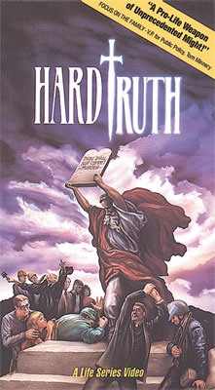
Actual footage of living, in-utero children and their aborted peers shows the hard truth about abortion in ways 'just words' never will. Hard Truth packs such unprecedented power, viewers cannot watch it without being profoundly affected. The video length is designed to fit into presentations. Guide for leading discussion is included. This video is powerful and very graphic. 10 minutes.

