Honest Answers
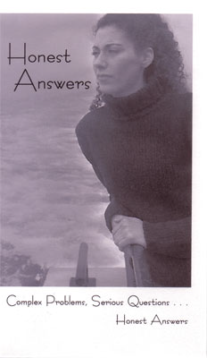
DVD, Complex Problems, Serious Questions... Honest Answers
”I just want this problem to be gone! I can’t have a baby now”. Thoughts like these swirl through the mind of a woman facing an unplanned pregnancy. Fear, confusion, guilt and anger battle it out as she tries to find a path that will lead her „back to normal.” Although she may cringe at the thought, abortion may seem to be the only option that will guarantee she will get her life back under control.
Honest Answers, a brand-new film for women facing crisis pregnancies, sensitively and candidly tackles the issues surrounding an unplanned pregnancy. Selena Lin, M.D. describes the physical characteristics of a pre-born baby at different stages of development, as well as abortion procedures and the accompanying risks at each stage. Interwoven with these facts are the testimonies of women who have had unplanned pregnancies. Whether they choose adoption or parenting, women from all walks of life speak with poignancy and openness about their experiences. A woman facing these tough decisions can hear for herself some of the feelings and concerns she is experiencing as these women share their raw, honest, and unscripted stories.
Anyone talking with a woman in crisis pregnancy will find Honest Answers an invaluable resource for helping her understand the truth regarding her options, while providing a moving look at the personal stories of women in similar circumstances.

