Silent No More Awareness
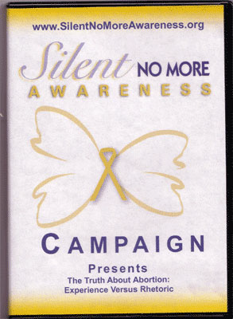
The National Silent No More Awareness Campaign is an effort to make the public aware of the devastation abortion brings to women, men, and their families. The emotional and physical pain of abortion should not be shrouded in secrecy and silence, but rather exposed and healed. As we are silen tno more, society will see that abortion hurts and doesn't help.

This DVD contains: One 28 minute Presentation of the Campaign, one 14 minute Presentation of the Campaign, one 60 second commercial and two 30 second commericals, and 11 full-length personal stories, including one in French.

