What About Abortion?
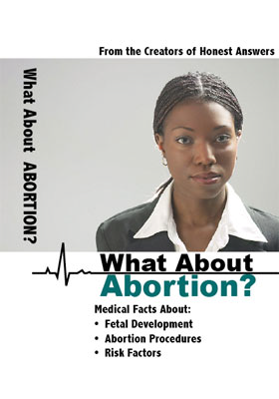

NEW! From the creators of "Honest Answers," comes a brand-new DVD for women facing crisis pregnancies. What About Abortion? provides honest answers to medical questions about abortion. Set in an interview format, Emily Aiken, speaks with two health-care professionals about fetal development, abortion procedures, and risk factors for abortion.
Guests include:
*Dr. Allen Moore, M.D.-an OBGYN and Fellow of the American College of Abstetrics and Gynecology.
*Julie Dozier, a Licensed Professional Counselor
DVD is 19:26 minutes. Year of production-2006.

