In the Wake of Choice
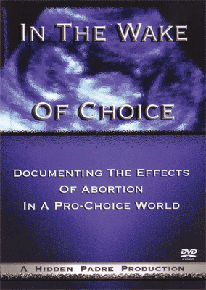

NEW! Documenting the Effects of Abortion in a Pro-Choice World.
Filmmaker Miguel S. Campbell follows Ann Marie Cosgrove as she talks with people affected by aboriton. Women, men, families and freinds bravely share their stories. See the pain of living with a terrible secret. Come to understand the suffering in silence. Experience the journey toward healing. Find the hope that beings to grow. We live in a world full of choices. This film documents the effects of abortion in a pro-choice world. 82 minutes.

